Tallahassee Mountain Bike Association
July Board Meeting Minutes (Pending Approval)
7/5/2023 at Dreamland BBQ

Board Members Present: Kat Sack, Matt Coniglio, Doug Draughton, Andrew Pederson
Non-Board Members Present: Richard Shoop

Minutes
- June meeting minutes were approved

Membership Updates
- Current Membership at 254
- (Pending Approval) Minutes should be sent out to membership promptly after meetings
- Next month’s agenda should be started once the minutes have been emailed to membership. Agenda should be sent out to members prior to meetings

TMBA Merch
- TBD tshirts remaining and for sale
- TBD Lucky Goat 50 bags remaining for sale
- Tank Top Order – Many members have an interest in tank tops, especially since smaller sizes were not represented well in the t-shirt order. The artwork will display the TMBA logo on the front and to select a color on which black print will show up for a more cost-effective order.
- Discussed a future jersey order and decided to table for later since a tank top order is the first priority. Noted we need to discuss pre-orders, whether or not to have sponsors, and to get feedback from the club on design
- Engraved ESI TMBA grips – A motion was made, seconded, and approved for $300 to purchase custom grips as a giveaway item at Trail Work Days. Other potential merch (work aprons) was discussed for future giveaways.

Gear Swap Recap
- June Gear Swap was a bust due to a heavy storm at Tom Brown Park that started right after everyone setup and lasted for over an hour. No plans to re-schedule but potentially open to a late Fall swap

Community Survey
- Matt brought printed out copies. Last chance to modify the survey – sending it out over email to TMBA members

Tax Exempt Certificate
- Doug B and Kathy need to look into the renewal

Website Updates
- Board meeting minutes are getting added
- Need to be more prudent about keeping the calendar up-to-date
- Doug B has a list of items to be updated
- Post a link on how to report trail issues between city/county/state/etc.

Public Meeting Updates
- 6/27 - Thomasville Rd Trail Widening (Andrew)
  - An open forum to reach out to project managers and engineers. Runners, roadies, etc. were in attendance advocating for it. Andrew vouched for TMBA’s support, and they asked if our riders will use it. Yes- It provides safer access to trails in more areas as many mountain bikers do not enjoy riding on roads.
- 6/29 - SR 267 Bloxham Cutoff Multi-Use Trail Public Meeting June 29
  - Barry Wilcox attended and reported to Matt C. This is an extension of St. Marks Trail to Wakulla Springs. Appears to be no opposition.

Annual Awards
- Need to establish a process an official end of the year award (related to volunteering)
  - Nominations, selection committee, board members eligibility

Social Events
- Club social at the Hub potentially Friday August 18

Trail Etiquette Meeting on 10/21
- TMBA needs to representatives. Need to send out notice to membership for their feedback.
- Discussion of including one-wheeler group to meeting since they also use trails

Fall Trip
- Board addressed this would be a last-minute trip but to try to keep it within a 4-hour radius.
- Ideas included Croom, Santos, Tampa, Alafia, Virginia Key, Chewacla, Standing Boy

Work Days
- Finish Fern/Bog - Need to finish half the skinnies, and complete drainage on features. We have excess lumber to build more features. 7/15. Ology parking then drinks/pizza
- Need to trim K-Rash which we have permission to ride and maintain

Summer Time Trials
- Recap of the first time trial at Munson
- Next is 7/17 at Lake Overstreet
  - Matt needs 10-15 cones for the intersections
  - Volunteers needed to help set-up/clear signage
  - Ideally set up the tent/flag and have shirts for sale

Holiday Party
- Need to set a date. Potentially 12/9 late afternoon/early evening
- Need to set a budget next month

Trail Reports
- Need to look more into info from Digitally as to who is reporting (walkers, runners, bikers).
- Reach out to whomever is parsing the submitted data

Group Ride Committee
- Insurance Coverage – Rides are covered but leaders are not
- July All-Levels Rides
  - 7/9 – Tom Brown Ology Social Ride led by Doug and Steph
  - 7/23 – Pending but aiming for FSC course (2 groups). Kat can lead.
- July Women’s Rides
  - 7/15-16 weekend for an intermediate ride
  - 7/29-30 weekend for an all-levels ride

Treasurer Reports
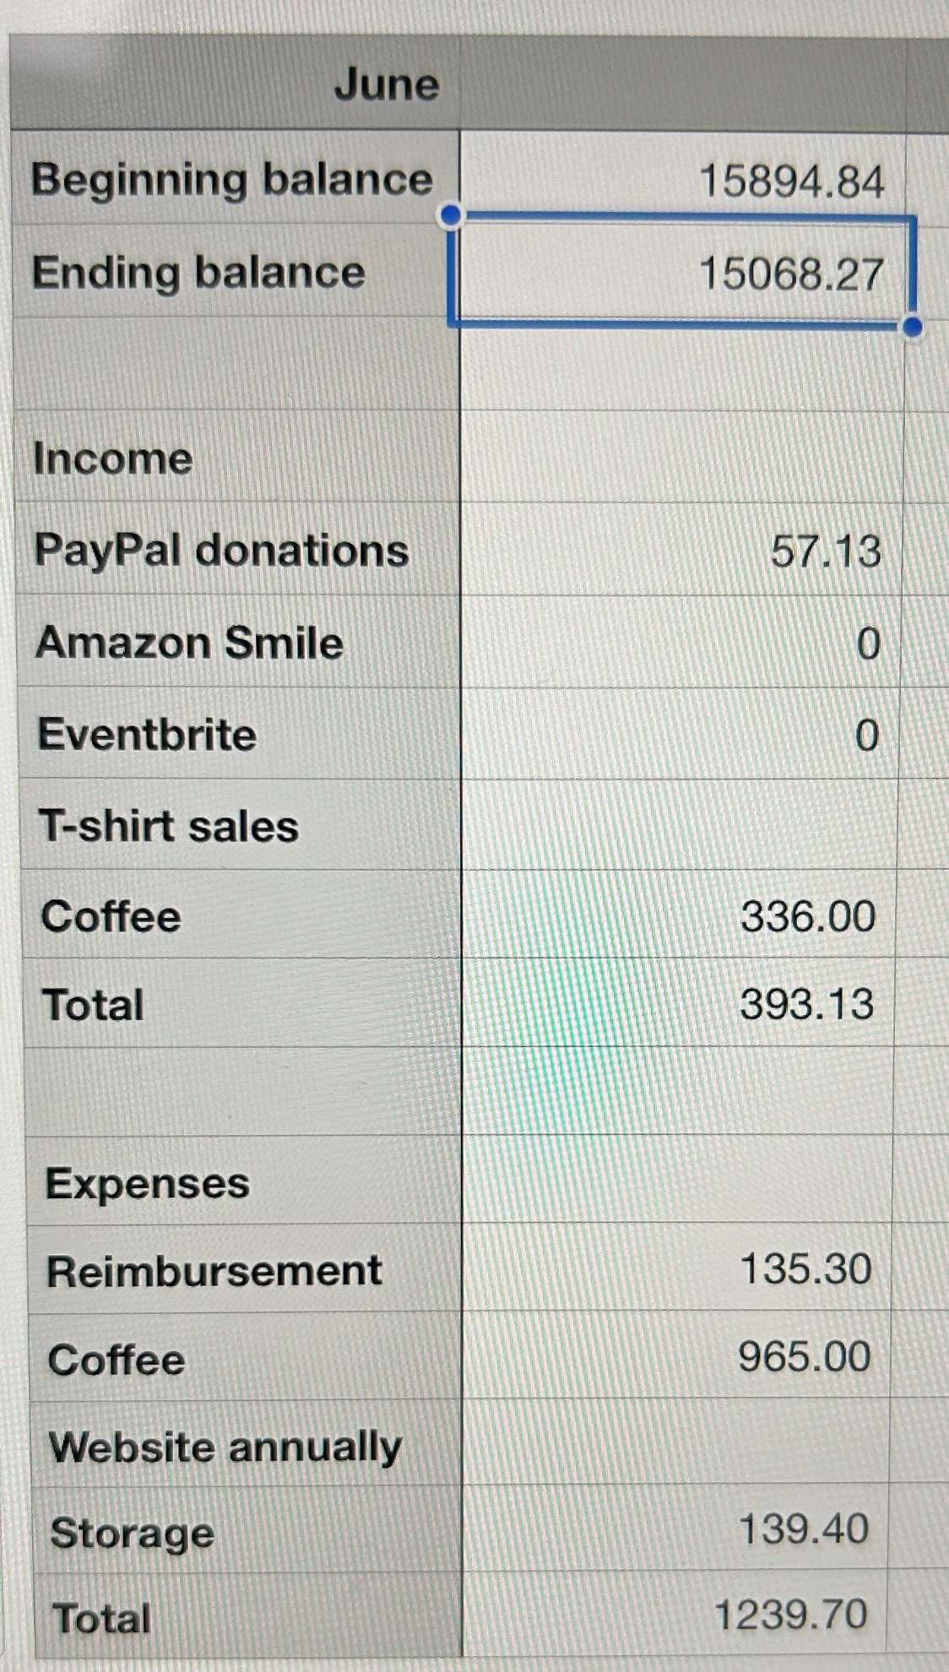
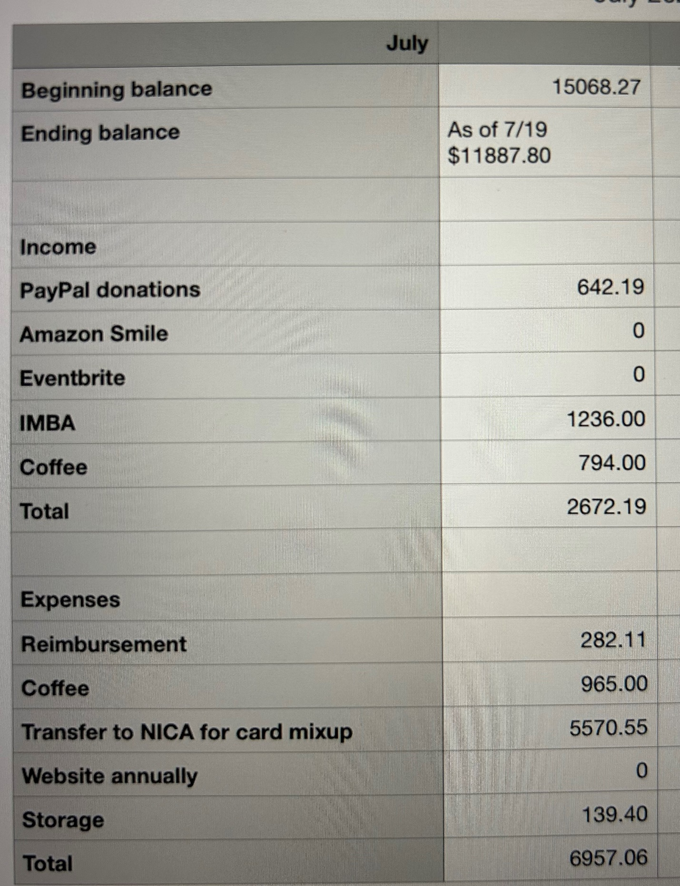

Open Forum
- See if county has marker numbers for their reporting app or if they have plans to do so
- South Florida uses pavers for places that collect water. Consider doing it on features that have some grade.

